Mental Health Response Advisory Committee (MHRAC)
Meeting Minutes
April 19, 2022
Via Zoom

Board Members in Attendance
Maxwell Kauffman Disability Rights New Mexico
Rachel Biggs ABQ. Health Care for the Homeless
Betty Whiton NAMI
David Ley New Mexico Solutions
Coty Maxwell APD Crisis Intervention Division
Gilbert Ramirez CABQ-Dept. of Family & Comm. Services
Laura Nguyen Albuquerque Ambulance
Matt Dietzel APD Crisis Intervention Division
Paula Burton NAMI Peer Representative
Rob Nelson APD/CIU/C.O.A.S.T
Mariela Ruiz-Angel Albuquerque Community Services
Emily Jaramillo Albuquerque Fire Department
Joe Aranda Hopeworks
Wendy Linebrink-Allison New Mexico Crisis Line

Introduction to MHRAC
The Mental Health Response Advisory Committee (MHRAC) was created by the Court Approved Settlement Agreement (CASA). We’ve been around since day one and have a focus on three areas, resources, and resources being available to access different things within the city that APD and first responders can use as it impacts homelessness and mental health issues. We are also involved in training and policy; training is one of those things we made a tremendous impact on. As far as the training that is offered. Policies are one of those things where the MHRAC is involved with assisting in writing and approving and recommending policy as it relates again to the narrow focus; we think narrow, but sometimes it gets pretty wide focused on how law enforcement interacts with those experiencing homelessness and those experiencing a mental health crisis.

Roll Call, Max Kauffman
Fourteen Board Members were present (names listed above)

Welcome first-time guests
Christopher Ferguson
Officer for APD, Southeast Area Command, and MCT Backfill

Dave Stein
Attendee

Frank Baca
Officer for APD, Valley Area Command, and former Crisis Intervention Division. I am transitioning back from military deployment

Mary Perez
Associate Chief Nursing Officer at UNM

Traci
Director of Admissions, Haven Behavioral Hospital

Jennifer Chacon
Lieutenant for the Albuquerque Police Department (APD) and a representative for the APD Academy

Approval of meeting minutes
1st Motion – Rachel Biggs
2nd Motion – David ley
Minutes for the March meeting were approved

Public Comment (Two minutes per person)
Sgt. Tinney
I would like to give a public shout out to COAST, they are helping people go forward
.
Gibson Health Hub, Family and Community Services, Cristina Parajon
The biggest update is the RFP, we received applications for the Gateway Center, Phase l, and that RFP had two scopes. The first scope was to serve 50 females identifying individuals and to be low barrier shelter, so those are beds. The second scope was the first responder drop off which is for all genders and that is serving low acuity individuals who just need a place to land for less than 23-hours and help connect them to services. That first responder drop-off is not a Crisis Triage Center.

The Good Neighbor Agreement went out last month, so we are now in the process of scheduling a time to sit down with the neighborhoods and discuss that draft.

We also began the demolition for the construction of the Gateway Center which includes the Engagement Center and the first responder drop off.

We are very close to finalizing Medical Respite and Sobering Center Designs. There are two other pieces that the city is building out at the Gibson Health Hub, a Medical Respite which is a place for people experiencing homelessness to rest before going into surgery or if they’re sick to prevent hospitalization and also post-operation or post receiving medical care to recover from that procedure in a safe place.

The Sobering Center is a complement to the Cares Campus and is medical sobering for low acuity individuals who are not inebriated enough to go to the hospital but you’re not quite at the level of a social model at the Cares Campus. So, we’re sort of filling that in-between with that. Upon completion, we’ll welcome about 20 individuals to each of those programs. All these programs are set to open at the end of 2022.

Nancy
Q. What is inebriated enough?

Cristina
A. Yes, those levels will be determined as soon as we get a service provider on board, but we have done a whole study on what exactly we need to fill in.
Gilbert Ramirez
In working closely with the county understand their exclusion and inclusion criteria and the gap area that we really wish to be able to catch those who aren't going to necessarily have compounding issues that need ER treatment. We've talked to AFR and I think roughly right now, they identified probably about 17 patients a night that would meet their criteria that otherwise are going to the ED or ER, so that is substantiation for why up to a 20-bed facility per night 24 hours. We hope they would be more stabilized and they would meet the criteria for either care campus social model and are entering into detox, so that's kind of that collaboration and crossover continuum of care we want to be able to meet but more importantly, have an alternative place for folks like ACS, AFR, and our Police to take those who are already rated and probably not ambulatory, to a place for that support. So that's been built out. We are going to probably be working with our Subject Matter Experts (SME) as we look at you know what parameters we need to also include, as we draft the RFP and then get this out the door.

Laura
Q. I'm wondering if the city has any ideas or plans for the rest of what is an enormous facility; what are you going to do with the rest of that space?

Cristina
A. When all the phases are complete, we will probably occupy about 25% of the building; the other 20% is already occupied by tenants. Providers who are interested in joining the health hub are definitely welcome.

Jeremy Lihte
Q. Did you say it is NOT a Crisis Triage Center?

Cristina
A. Yes, the first responder drop off is NOT a Crisis Triage Center; that requires a certain level of certification and acuity

30:00 Max
Q. I have always found it problematic for a misdemeanor or petty misdemeanor warrants to be part of an exclusionary criterion, or services such as detox. Is that going to be an exclusionary piece to a sobering center?

Cristina
A. I don’t think we are that far ahead; Gilbert, correct me if I am wrong.

Gilbert
A. No. In addressing that issue where we want to make sure that most of the cases that will probably come from the Sobering Center are going to be triaged in the field, so I can’t speak to what processes will happen out in the community. Our focus and goal are when they get to the Sobering Center that they get the medical service they’re going to need for that oversight.

DC Jaramillo, AFR
A. As for EMS, we don’t have the ability to run our patients for warrants.

Nomination of new board members, if any, Rachel/Max
No Nominations were presented

Albuquerque Community Safety Department update, Mariela Ruiz-Angel

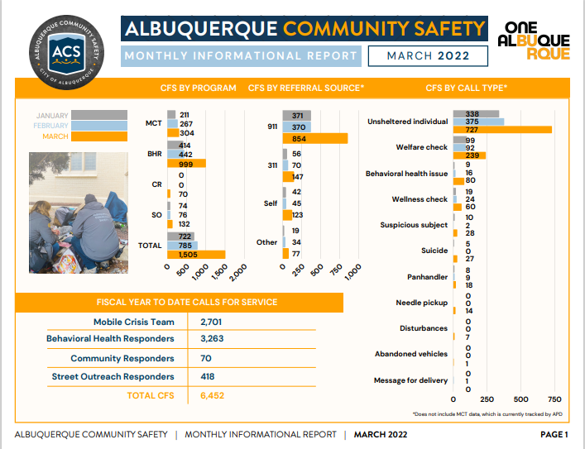

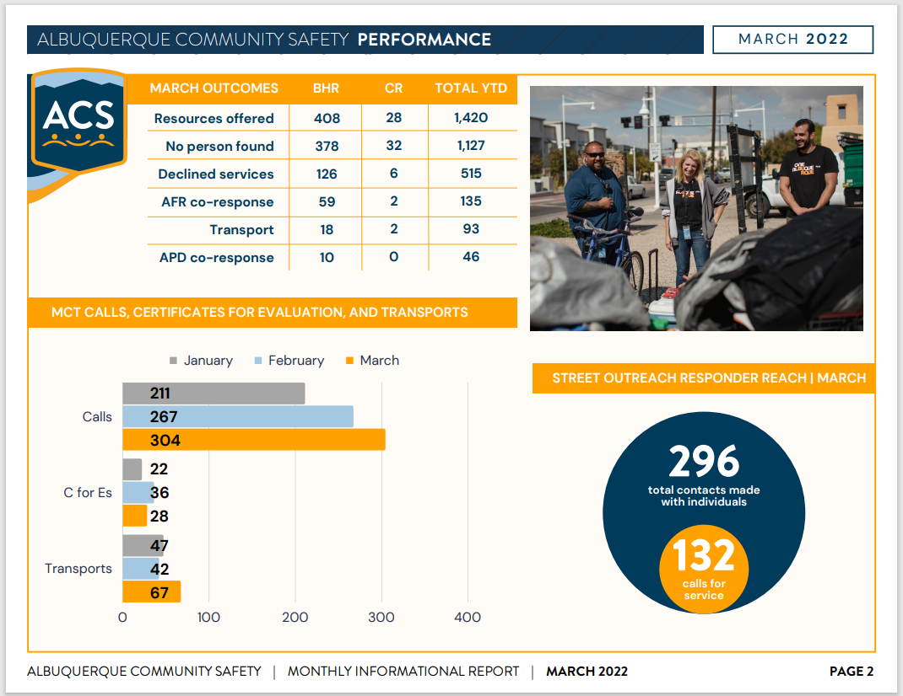

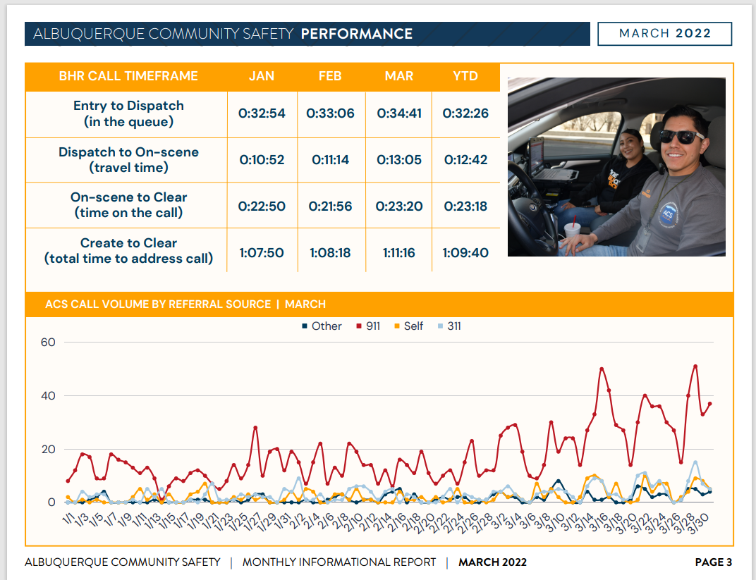

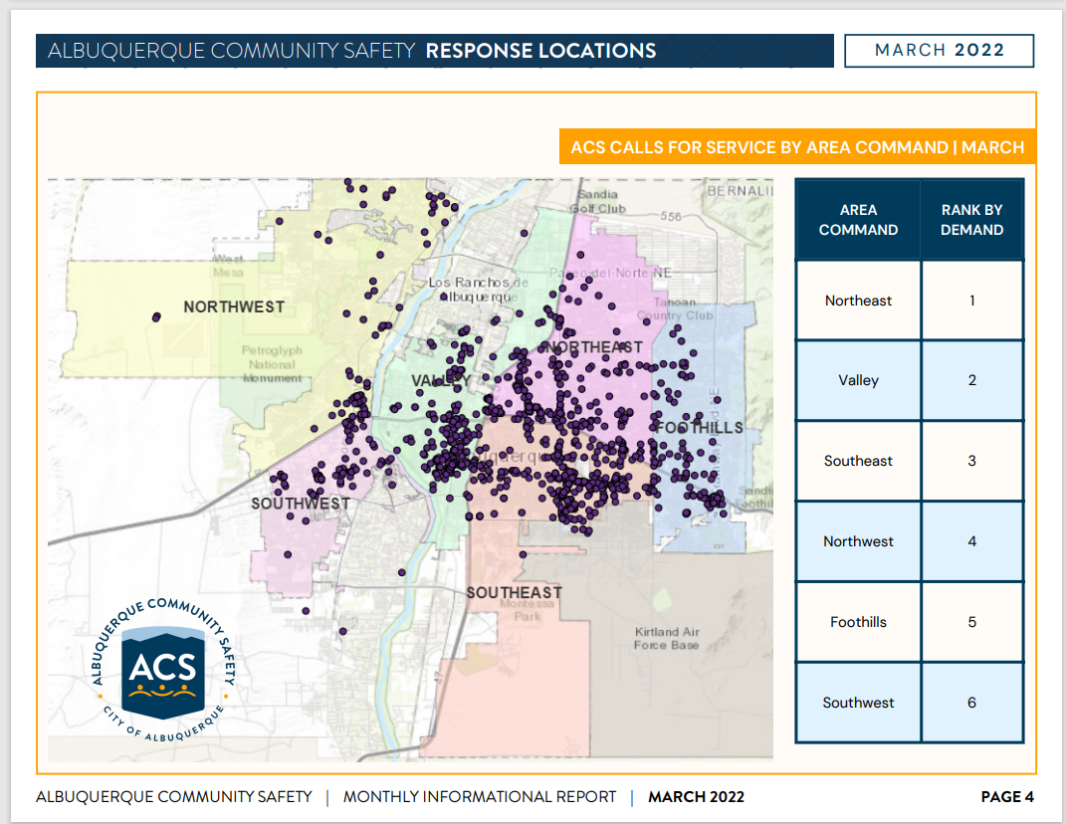
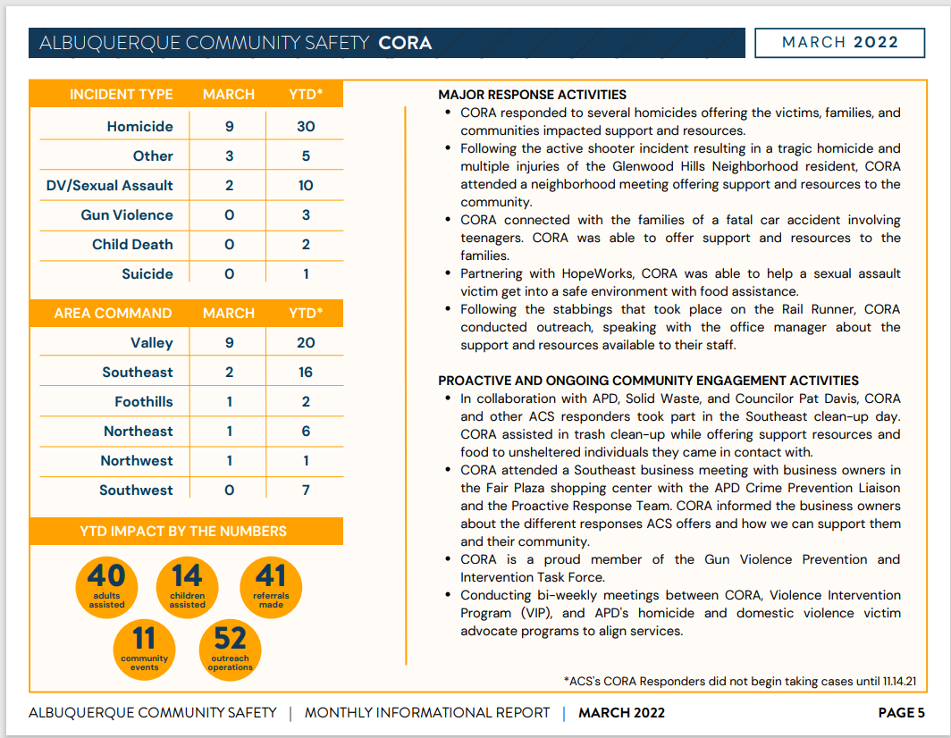

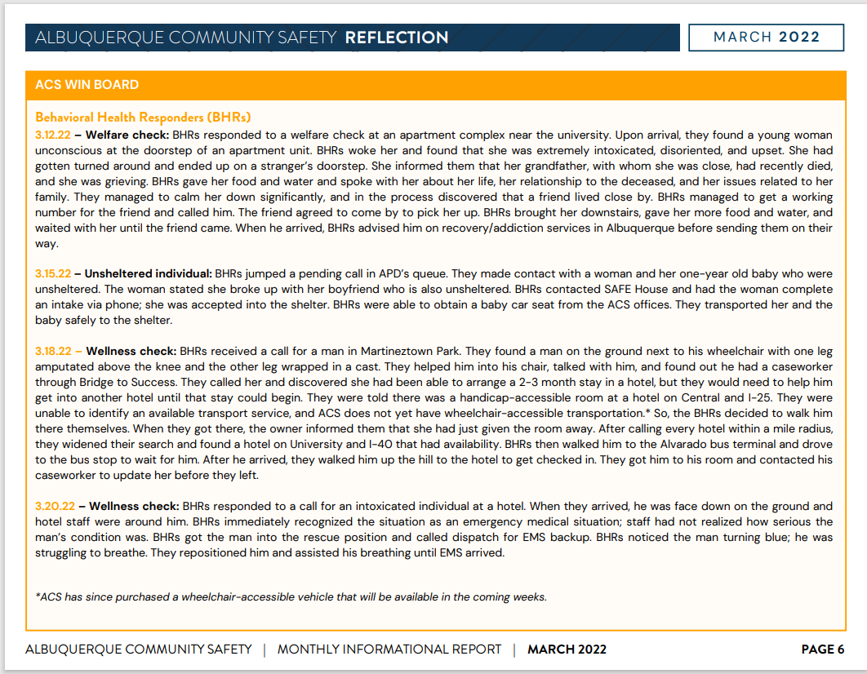
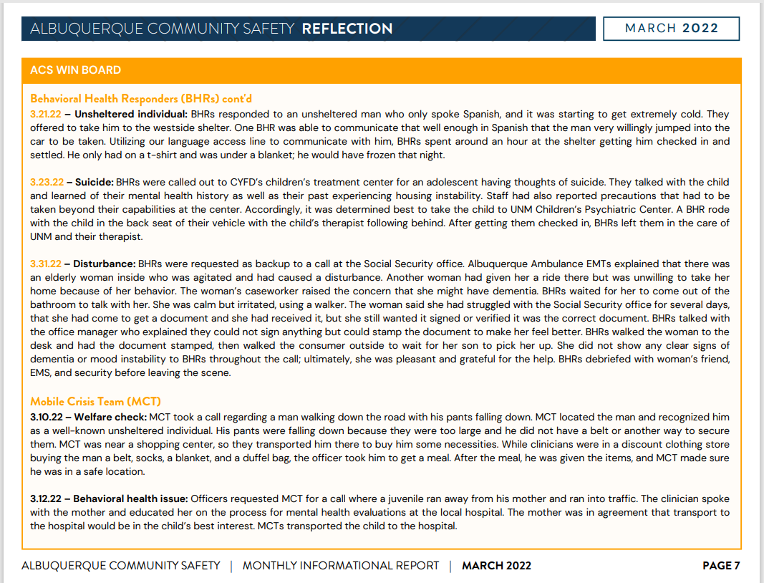

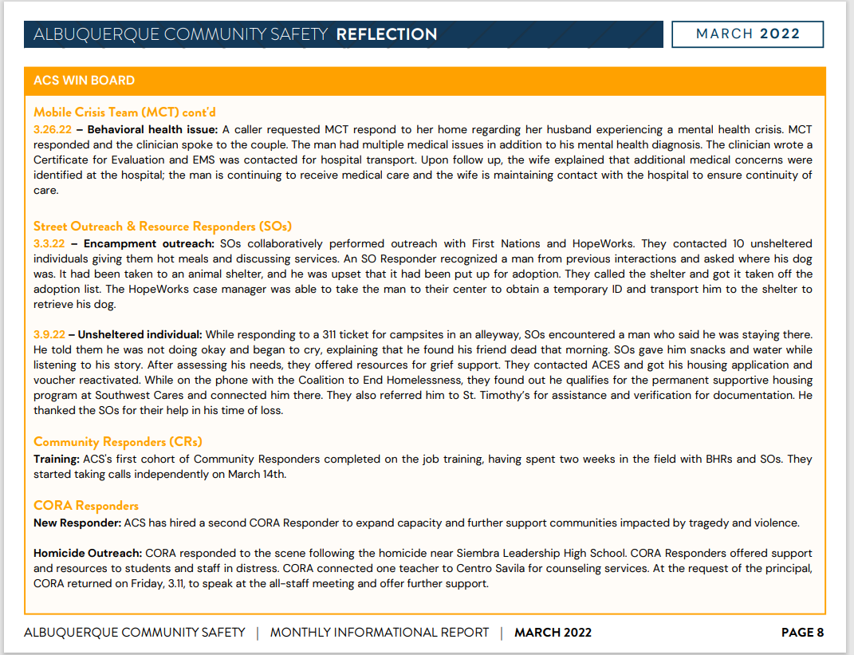
Rachel
Q. Are the numbers that you already put out, are they unique individuals, or are they duplicated?

Mariela
A. We haven’t necessarily hashed the two out; some of them are duplicated. We will start to track that as we move into a new database.

Rachel
I would like to remind everyone to help each other out when it comes to acronyms, if we can spell out what the acronym is, that would be very helpful. (i.e., Albuquerque Police Department (APD), Mobile Crisis Team (MCT), Albuquerque Community Services (ACS), Albuquerque Fire Rescue (AFR), etc.)

Celia Yapita
Q. on the chat: Are the welfare checks only for those experiencing homelessness or for anyone, including those living in homes?

Mariela
A. It’s anyone, and we will go into homes. We do have a process for how we handle that; the protocol is depending on the situation.

Joseph
Q. You said you had to gauge responders at dispatch; is there a different level of certification that responders have, or is it the same across the board?

Mariela
A. No, both of the individuals who are there currently are at a higher level. They are tier two behavioral health responders. That doesn't necessarily qualify them with that position; it was really meant to be what we consider to be a rapid experiment. Other cities that we've seen do this well, like Houston and Austin, and Phoenix. We've just seen really good results. I think for us, we were just trying to see, would this work like would this be a good fit? I think we want to give it at least a quarter, so probably till the end of the fiscal year to see what the numbers look like, and then we can figure out what that would look like going forward into the new year and how we would stack that up.

MCT Training, Statewide Update, Betty Whiton
The City of Albuquerque Community Services Department is going to fund sending Detective Mike Sciarrillo and the clinician’s trainer to a National Conference for Mobile Crisis Teams with the understanding that they will come back and do a training for ACS, APD, and BCSO Mobile Crisis Teams, the County Fire Mobile Crisis Team as well.

I am on the Mobile Crisis Teams sub-committee. How do we set up Mobile Crisis Teams around our huge rural state; I suggest looking at the model of MCT you all have developed here and looking at it legislatively.

Behavioral Health Initiative (BHI, Betty Whiton
The BHI Crisis Triage Center at UNM is on target and the land is appropriated. The architectural design is appropriated and should be in place very soon.
Law Enforcement will have someplace to take people and it will be dealt with; it won’t be, “well we’re full.”

Nancy Martin
Q. Does the BHI plan to address DD Waiver patients who require housing?

National Alliance on Mental Illness (NAMI) Update, Betty Whiton
NAMI has been approved to add a new affiliate in Farmington for san Juan County which will be handling the four corners area which gives us a total of four affiliates.

I am a state trainer for SYSLE = Sharing Your Story with Law Enforcement and I will be training new presenters. I have 30 people who want to be trained and want to present. We do APD, ACS, and PSPG so we can reach outside the city. The panel is in great demand.

I am on the 988 committee

Behavioral Health Initiative, Charlie Verploegh, Ph.D., Assistant Director

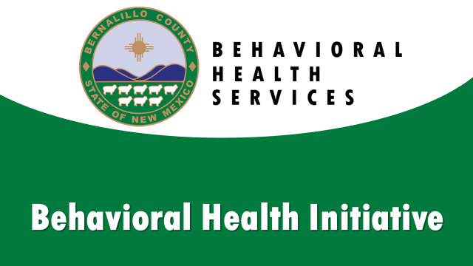

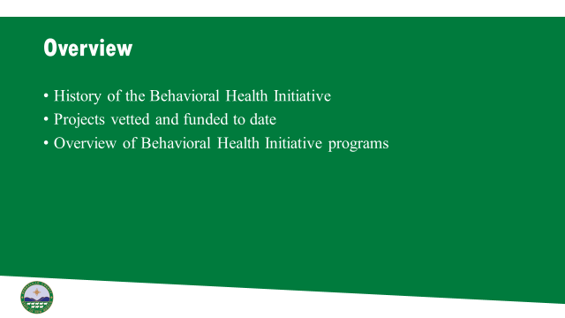
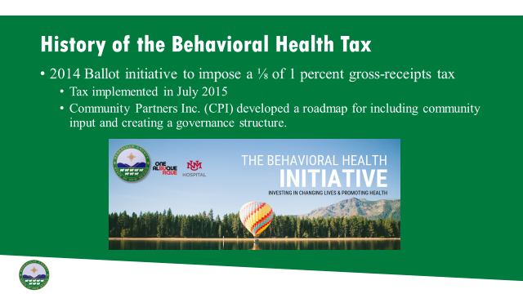

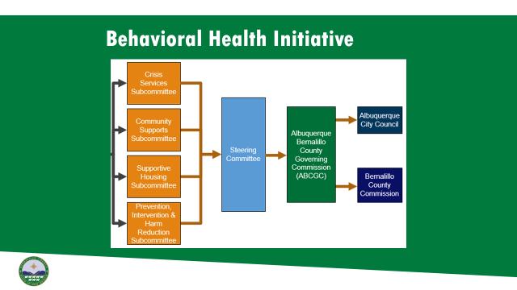
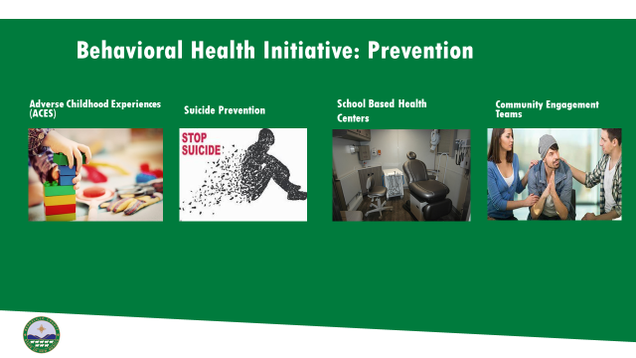

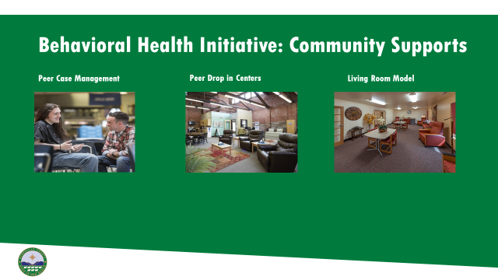

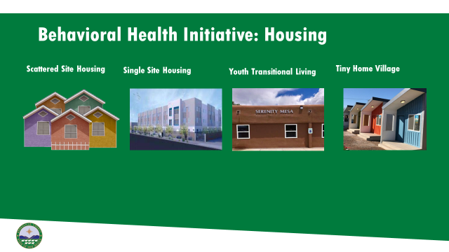

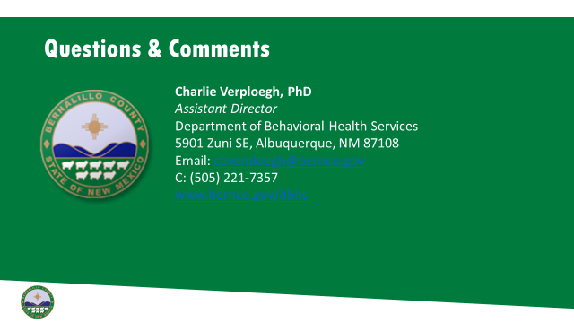
Charlie
We're in the process of doing a marketing contract with the marketing and advertising firm.
The ACES program is really for at-risk children and families that might need services across the spectrum. So prevention, identification, early intervention, support, treatment, and harm reduction. There are eight providers in this area. We have a school-based health center that will be up and running soon. We will be purchasing two big medical RVs that will be going out into the community, APS schools, and Charter schools to provide behavioral health and medical services rights to the youth in those locations.
We have a scattered-site program that's basically apartment complexes across the city that have case management wraparound services included, so you get a voucher, but you also have to participate in case management services. That's for maybe a little lower acuity client who might be able to live independently and just have a check-in maybe once or twice a month from a case manager. Then we have a higher level, which is the single-site program, which is 42 units in one complex, where we have pretty robust services right there on-site, including an ACT team, psychosocial rehab, a very robust case management team that works with those clients to make sure that they're stabilized because they're coming from pretty difficult circumstances where maybe they've been chronically unsheltered or significant substance use disorder throughout their lifetime and learning to navigate that and move away from being unsheltered into a sheltered lifestyle and so working with services to move into that transition. We have youth transitional living services that are great for kiddos in that transitional phase.

Max
Q. Are you able to speak more on the availability of special education-related services within the youth transition services or is it something that the county might be open to meeting with DRNM to discuss how we can develop and tap into that resource?

Charlie
A. I'm not as familiar with special education components as it might relate or intersect with behavioral health that could see some intersection and opportunity for collaboration

Nancy Martin
Q. Does the BHI plan to address DD waiver patients who require housing?

Charlie
A. That's not something that we have done up to this point. The housing programs that I described are the ones that are funded at this time and you know, it's really unfortunate because the tax seems like a lot of money. But once we went through the first three or four years or so we allocated it all out. And so it's not to say that there aren't opportunities to make some have some flexibility and some shifts were needed. But currently, there aren't huge gaps where we can pull funding so for example, if we have 3 million allocated to ACES, we would have to cut our ACES programs to be able to fund another housing program, but we are constantly evaluating our programs.

Betty
Since 2015 we have been hoping to have a Crisis Triage Center to help deal with mental illness crisis at the university and that is going to happen. We will have a place where Law Enforcement won’t have to wait in long lines and then be turned away because the beds are gone at Kaseman or UNMH. This is a partnership and collaboration between Behavioral Health Initiative, CASA, and MHRAC.

Briget
Q. I was wondering if the ACES program works with the Department of Health and their birth to three programs for kids that are developmentally delayed who also qualify if their family does have ACES?
Charlie
I'm not sure; I think I'd have to reach out to our providers and ask them if they're collaborating.

CIU, APD, and BSS Report and update, Commander Dietzel
Announcements: The County and UNM invited us to a meeting at the Crisis Triage Center recently where members of the Mobile Crisis Team (MCT) on the officers' side got a chance to talk about the drop-off and how they would like that to look. We talked to the architects from that project about the kind of things that police would like and it would be convenient for us it will make the drop-off smoother and quicker. We got to talk to the architects about the things that the police would like.

COAST Update, Rob Nelson
Briget Ledger, the newest COAST member is done with training and is out on her own and doing an awesome job.

Sgt. Tinney
We have an opening for a new detective; we will be interviewing in May.

Have seen a lot of news about elevated individuals that are wanting to take their lives? Our CIU detectives have done an outstanding job on all these barricades and elevated individuals. Our Crisis Negotiation Team (CNT) has been working closely with the new SWAT team and trying to figure out a new plan for when they respond to calls of barricades. But in that time we've been able to help out in the field. This is one area of the police department that still has a passion.

Sub-Committees Report and update
David Ley
Training Sub-Committee Update: We talked about dealing with barricaded suicidal individuals. We had a good conversation about the developing collaborations between AFR, ACS, and APD, and how that is working. We started some discussion around Reality-Based Training; we have some training documents to review for this.

Infoshare/Resource/Policy Sub-Committee Update: The sub-committee has done a phenomenal job of getting the resource cart. We have requests for quotes from the vendors; we are doing a large run so as soon as they come out we will let you all know.

The policy season has passed, at least for a while, policy has moved all the way through. We're in the final stages on the last two policies that concern mental health that has not been published; those are Response and the Unit SOP. I think it'll probably be in the next couple of weeks.

MHRAC Final Discussion (5 minutes)
Commander Dietzel
We had a meeting with the new director of The Rock at Noon Day, he informed us that they have Zoom capability there at The Rock if we want to start meeting in person at The Rock at Noon Day.

Max and Rachel
I would like to get some input from the committee on our first time using this new format; we had some hiccups, but we would like to continue a virtual option if we go back to meeting in person. We can always look into a hybrid format for the convenience of folks attending.

Next meeting: Tuesday, April 19, 2022

